Project Title
MedAssist AI – Medical Symptom Analysis and Disease Prediction System

Submitted By : Gorrepati Lokesh Babu

Role
Frontend Development – Login and Registration Page Design using HTML, Tailwind CSS, and JavaScript

1. Introduction
MedAssist AI is an AI-powered healthcare application designed to predict diseases based on user symptoms and provide healthcare recommendations. As part of the frontend development team, my responsibility was to design and develop the user authentication interface. This includes creating responsive Login and Registration pages that provide a clean, modern, and user-friendly experience for users accessing the application.
2. Work Completed
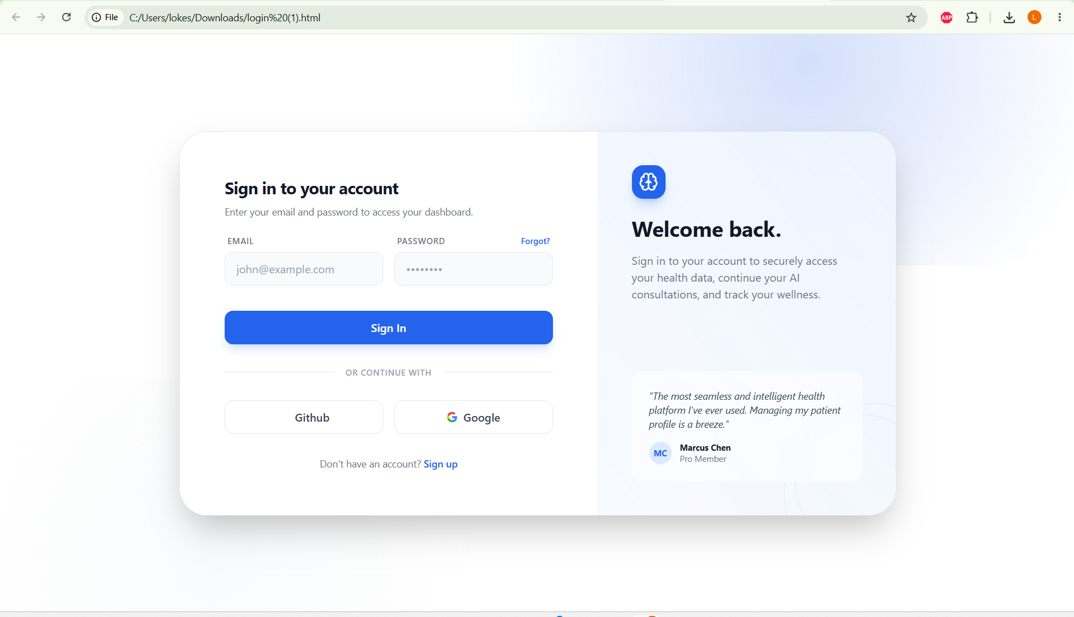



2.1 Login Page Development
- The Login page was designed with a modern and responsive interface using HTML, Tailwind CSS, and JavaScriptDataset 1: Disease descriptions, medications, precautions, diet, and workout recommendations.
The following features were implemented:
- Email input field
- Password input field
- Forgot Password link
- Sign In button
- GitHub Sign-In button (UI)
- Google Sign-In button (UI)
- Sign Up navigation link
- Responsive layout for different screen sizes
- Glassmorphism UI with gradient background

2.2 Registration Page Development

A responsive Registration page was created to allow new users to create an account.

The page includes:

First Name field

Last Name field

Email field

Password field

Create Account button

GitHub Sign-Up button (UI)

Google Sign-Up button (UI)

Sign In navigation link

Responsive design with consistent styling

2.3 UI Design and Styling
The frontend interface was designed using Tailwind CSS to provide a professional and modern appearance.
The implemented design features include:
- Responsive layout
- Glassmorphism effect
- Gradient background
- Rounded cards and buttons
- Lucide icons integration
- Smooth hover effects
2.4 Technologies Used
The frontend module was developed using:
- HTML5
- Tailwind CSS
- JavaScript
- Lucide Icons
- Responsive Web Design

3. Challenges Faced
- Designing a responsive interface that adapts to different screen sizes.
- Maintaining consistent styling between Login and Registration pages.
- Creating a clean and attractive UI while keeping the code organized.
- Integrating modern UI components using Tailwind CSS

4. Current Status
- Login page completed.
- Registration page completed.
- Responsive UI implemented.
- Authentication form layout completed.
- Navigation between Login and Registration pages implemented.
- Frontend authentication interface ready for backend integration.

5. Next Milestone Plan
The following tasks will be completed during the next milestone:
- Connect Login and Registration pages with backend APIs.
- Implement user authentication and authorization.
- Add form validation and error handling.
- Integrate database for user registration and login.
- Perform testing and frontend optimization.

6. Conclusion
During Milestone 1, the frontend authentication module for the MedAssist AI application was successfully developed. Responsive Login and Registration pages were designed using HTML, Tailwind CSS, and JavaScript with a modern user interface. The authentication screens are prepared for backend integration, enabling seamless user registration and login functionality in the next phase of development.

